PWD Specification

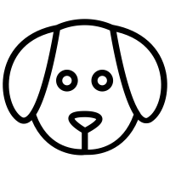

**Table of Contents**

1 Technical Requirements for PWD wearable tracker 4

1.1 Sender requirements 4

1.2 Receiver requirements 4

2 Possible HW solutions 4

2.1 S76G/S78G from ACSIP 4

2.2 ATSAMR35J16BT from Microchip 5

2.3 Component analysis 6

3 Lora Introduction 6

3.1 Introduction 6

3.2 Expected Lora Range 9

3.3 LoRa versus LoRaWAN 9

3.4 LoRa Chip types 11

3.5 LoRa Legal limits 11

3.6 Main issues affecting PWD use case 12

4 Lora Band analysis 12

4.1 RF868 band 12

5 Range analysis 15

5.1 Maximizing the link budget 15

5.1.1 RSSI and SNR 16

5.1.2 FSPL and other effects 16

5.2 Optimizing Link Budget: the Hardware way 17

5.2.1 Antennas 17

5.2.2 Receptor 17

5.3 Optimizing Link Budget: the software way 18

5.3.1 Spreading Factor 19

5.3.2 Bandwidth 20

5.3.3 Frequency variation 20

5.3.4 Frequency and temperature compensation 21

5.3.5 Coding rate 21

5.3.6 Bit rate 22

5.3.7 Maximize range Summary 22

6 LoRa Data packet 22

6.1 Low data rate optimization 24

6.2 Time on Air and Data Rate 24

6.3 Reducing the payload 25

7 Software 25

7.1 LoRa end node libraries 25

8 References 27

8.1 Radio theory basics 27

8.2 Waterproofing 27

8.3 LoRa Implementations 27

8.4 Power legal limits 27

8.5 LoRa Calculators 28

8.6 Microchip transceivers 28

8.7 Antenna testing 28

8.8 LoRa Packets 28

# Technical Requirements for PWD wearable tracker

## Sender requirements

The sender is embedded in the logo tag of the clothes so it has a very reduced size, is composed of:

GPS + GPS antenna + LORA chip + LORA antenna 🡪 SIP package

Battery – (possibly flexible), of long life (1 year) ???mA or allow induction charging - ???mA

Flexible PCB

Has to be waterproof (IP 68) with nano particle protection from nanoflowX -V3 solution

## Receiver requirements

The receiver can be attached to the case of the cell phone or just put in a key chain it does not have same size restriction and is composed of:

* Bluetooth + Lora chip + Lora Antenna
* Bluetooth connectivity is so that mobile phone App can receive the Lora messages and provide users with location information
* Battery – induction charging - ???mA
* Display to indicate information on sender activation and reception

Be waterproof (IP 68) with nano particle protection from nanoflowX -V3 solution

# Possible HW solutions

Two possible SIP solutions:

## S76G/S78G from ACSIP

* Variants:
  + S76G: SX1276 (Lora chip) + STM32L073x (STM Arm cortex-M0 CPU)+ GNSS chip (SONY CXD5603GF)
  + S78G: SX1278 (Lora chip) + rest is identical

**Note:** difference between 76/78 chips is the Lora Semtech transceiver

<https://www.semtech.com/products/wireless-rf/lora-transceivers/sx1276>

SX1278 can operate in 137-525MHz while SX1276 supports frequency 137-1020 MHz so for our purposes (use of 868MHz band we should select SX1276 or similar variants)

* Form factor: 13mm X 11mm X 1.55 mm
* Datasheet on CPU STM32L073x:

<https://www.st.com/content/ccc/resource/technical/document/reference_manual/2f/b9/c6/34/28/29/42/d2/DM00095744.pdf/files/DM00095744.pdf/jcr:content/translations/en.DM00095744.pdf>

* Product datasheet:

<http://www.acsip.com.tw/index.php?action=products-detail&fid1=19&fid2=&fid3=&id=41>

* Development board:

<http://www.acsip.com.tw/index.php?action=products-detail&fid1=21&fid2=&fid3=&id=103>

## ATSAMR35J16BT from Microchip

* Variants:
  + SAMR35 has several variants R35 has no USB (vs.R24) and J16 is the lowest memory variant with :LoRa SiP Transceiver 64K Flash 8K SRAM, 4KB LP SRAM, T&R
  + Need to add a GNSS SiP module. Example: <https://www.u-blox.com/en/product/zoe-m8b-module> (4.5 x 4.5 x 1.0mm) or <https://www.u-blox.com/en/product/eva-m8-series>
* Form factor: 6 mm x 6 mm
* Product datasheet:

<http://ww1.microchip.com/downloads/en/DeviceDoc/SAM-R34-R35-Low-Power-LoRa-Sub-GHz-SiP-Data-Sheet-DS70005356C.pdf>

* Development board: <https://www.microchip.com/DevelopmentTools/ProductDetails/dm320111>

## Component analysis

|  |  |  |  |
| --- | --- | --- | --- |
| Component | Form factor | Costs | Links |
| SAMR35JXX | 6 mm x 6 mm | 5,22 eur (250 pcs) | https://pt.farnell.com/search?st=SAMR34 |
| GPS ZOE-M8B | 4.5 x 4.5 x 1.0 mm | 12.99 eur (100-480 pcs) | <https://www.u-blox.com/en/product/zoe-m8b-module> |
| S76G | 13mm X 11mm X 1.55 mm | Could only find prices for S76S with no GPS ($13.00) | <https://techship.com/products/acsip-lorawan-module-s76s/> |
| Battery (just a starting point) | 20mmX20mm | 0,433 eur per unit (consumer market) | Example for a 40mAh: <https://bit.ly/2lVmXZR> |

# Lora Introduction

## Introduction

LoRa is an acronym for **Lo**ng **Ra**nge and it is a wireless technology that operates in the ISM (Industrial, Scientific and Medical) radioband. LoRA is a technology that has several benefits:

* Very resistant to in-band and out-of-band interference
* High immunity to multipath and fading
* Doppler shift resistant (applies to moving devices and high clock tolerance)
* Good sensitivity
* Simple receptor

The ISM band frequencies are as follows:

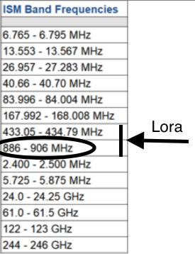

LoRa allows for low powered senders to transmit small data packages (0.3kbps to 5.5kbps) across long distances.

LoRa is part of a family of LPWAN – Low Power Wide Area Network technologies that compete in the same space (Like Sigfox and NB-IoT).

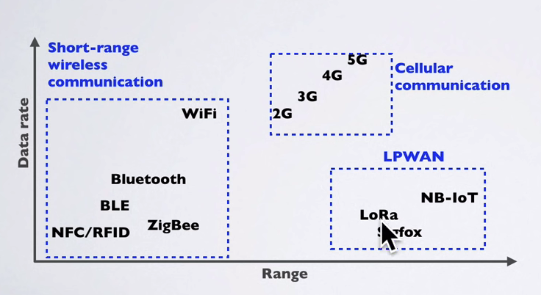

The diference between data LoRa and other technologies (e.g. 3G and 4G) is that LoRa has long range and low transmission power (compared with 3G/4G)

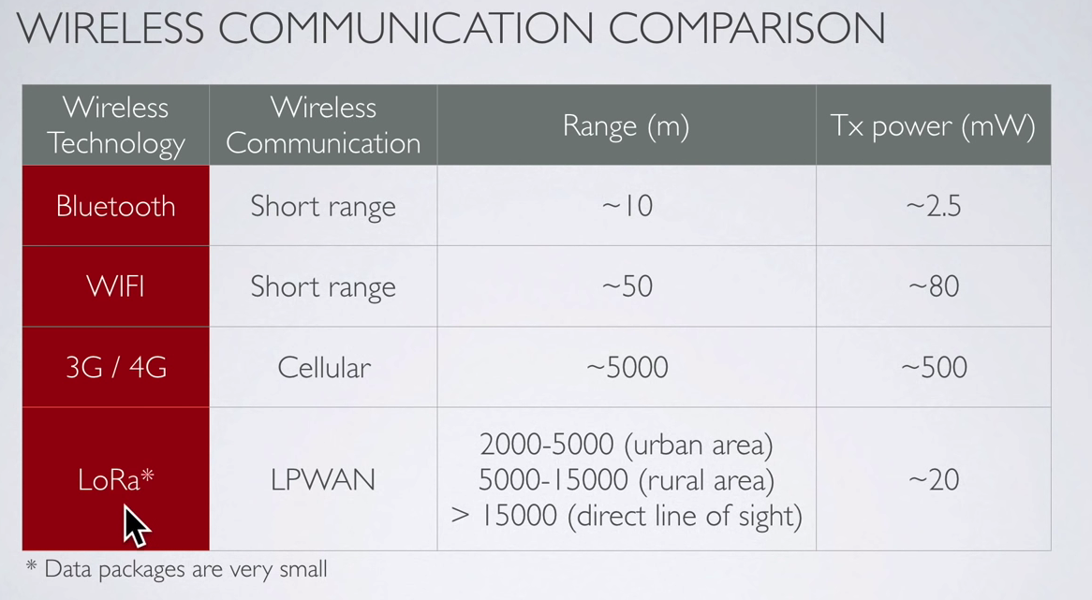

LoRa technology was developed by French startup Cycleo which developed the modulation technology (Chirp Spread Spectrum). In 2012 Semtech corp. acquired Cycleo. The LoRa radio and modulation Intellectual property (IP) is patented and the source is closed. The LoRa trademark is also patented. Semtech licenses the IP to chip manufacturers like Microchip, STMicroeletronics and HopeRF.

Following are examples of current boards in sale.

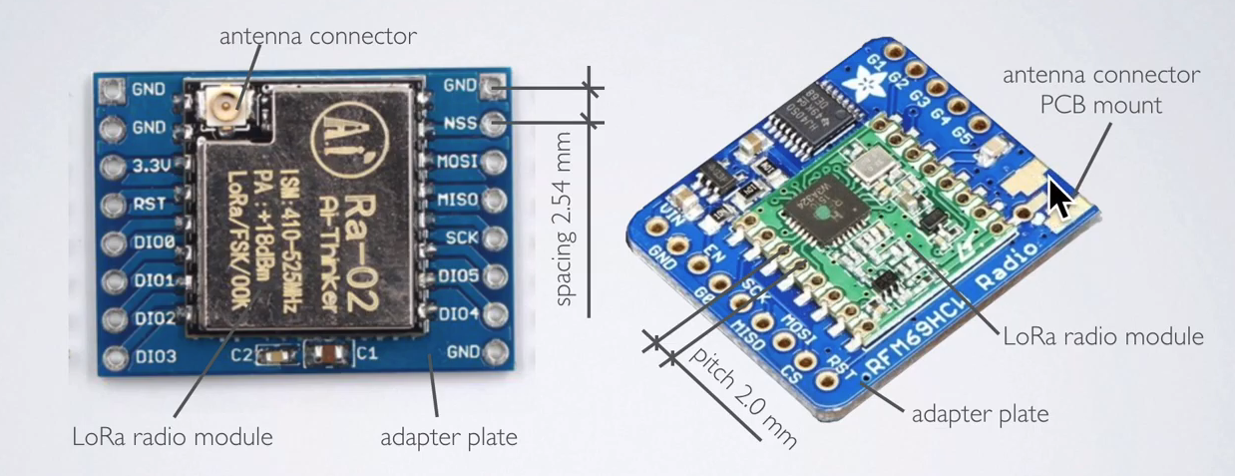

## Expected Lora Range

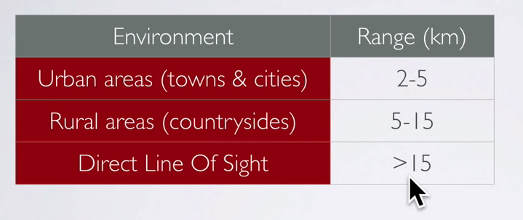

The main impediments to LoRa range is the environment:

* Buildings, mountains, trees
* Fresnel zone
* Jamming by other emitters

## LoRa versus LoRaWAN

Lora differs from LoRaWAN as follows:

* LoRa contains only the link layer protocol and is perfect to be used in P2P communications between nodes. LoRa modules are a little cheaper that the LoRaWAN ones.
* LoRaWAN includes the network layer too so it is possible to send the information to any Base Station already connected to a Cloud platform. LoRaWAN modules may work in different frequencies by just connecting the right antenna to its socket.
* Both are based on the same modulation technology (the same PHY layer): LoRa™, developed by Semtech. The LoRa module implements a simple link protocol. However, the LoRaWAN module runs the LoRaWAN protocol, a much richer and more advanced protocol, created by the LoRa Alliance.

So LoRaWAN is a complete network architecture that allows the nodes to connect to gateways and transmit to the internet.

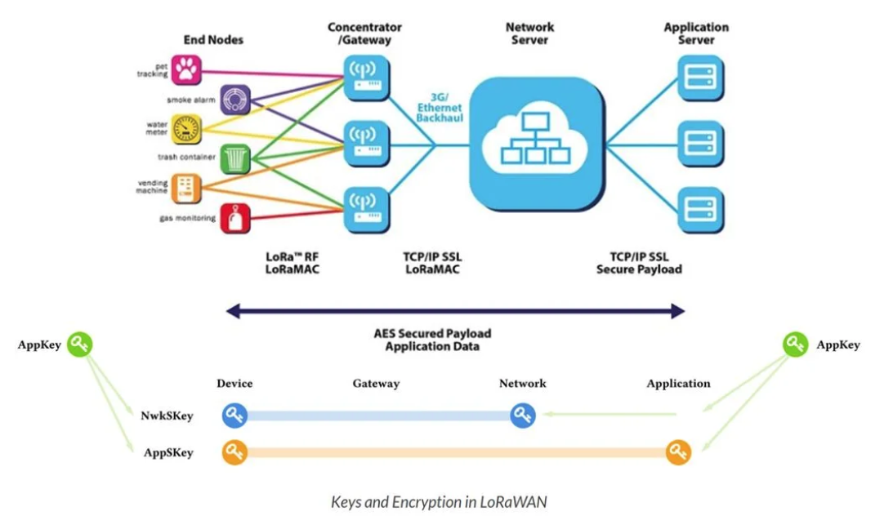

Figure 1 - What is LoRaWAN - https://lora-alliance.org/resource-hub/what-lorawanr

Here is a diagram that explain the stacks of LoRa and LoRaWAN

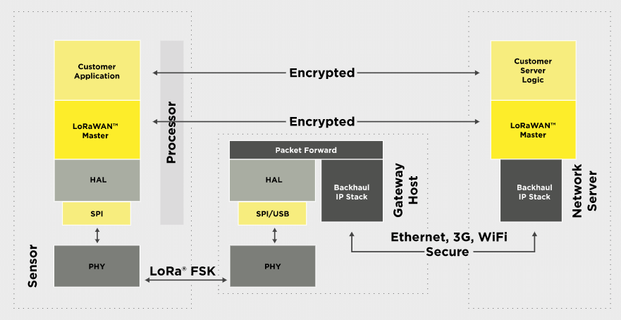

Figure 2 - LoraWAN Stack - https://lora-alliance.org/about-lorawan

However PWD is targeting mainly a point to point use case which only needs the LoRa technology and not the LoRaWan technology.

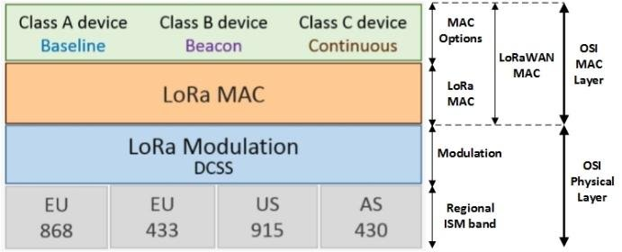

PWD

Figure 3 - Lora MAC - <https://www.researchgate.net/figure/LoRa-and-LoRaWAN-protocol-stack-6_fig2_331790920>

The Lora/LoraWAN packets and protocol stack are defined in the following way:

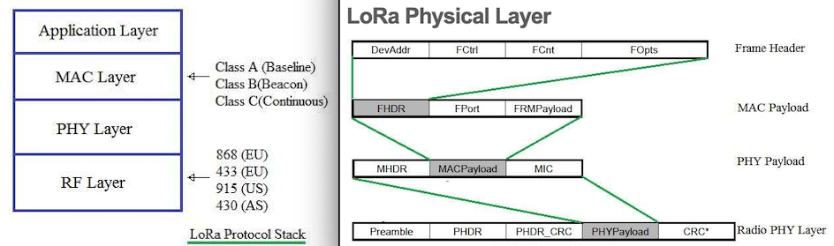

Figure 4 - https://www.rfwireless-world.com/Tutorials/LoRa-protocol-stack.html

## LoRa Chip types

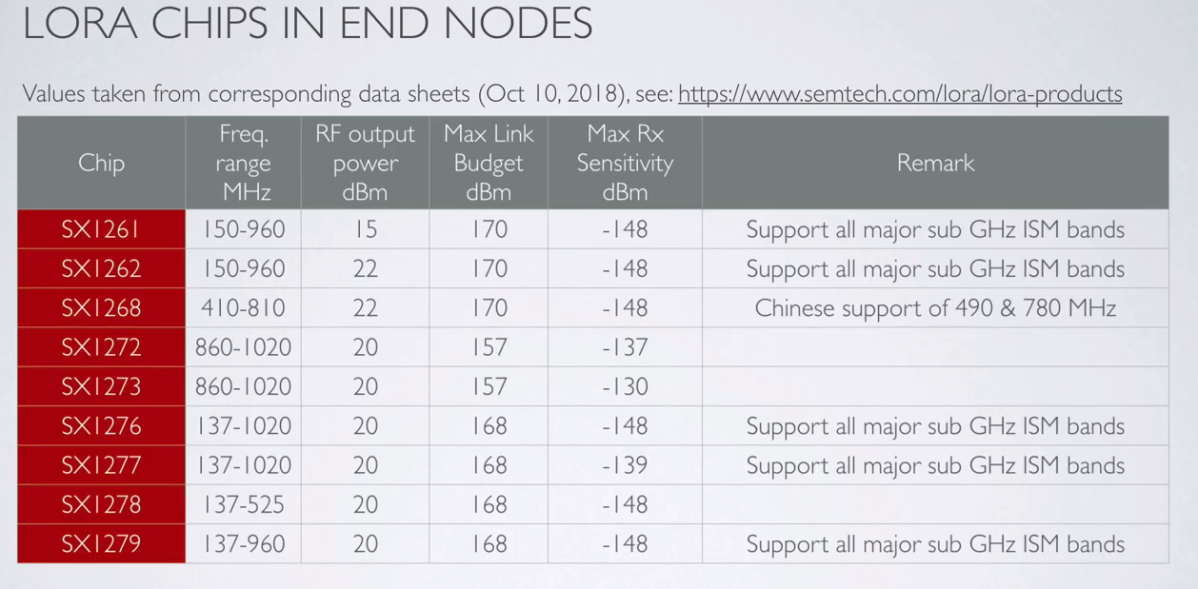

## LoRa Legal limits

## Main issues affecting PWD use case

The main issues affecting PWD LoRa use case are:

* Power utilization
* Legal channel utilization that is to respect the duty cyle.
* Jamming problems that is avoid collisions with other emitters in the region.
* Antenna design and placement

# Lora Band analysis

## RF868 band

The RF868 band is split into 6 different sub-bands and each have different utilizations and legal limits.

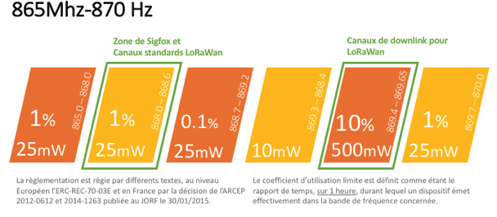

The bands use cases are as follows:

* The first band: 865-688.0 MHz has 300kHz and is a 25mW / 1% duty cycle usage ruled band, it is used by RFIDs.
* The second band: 868.0 to 868.6MHz has 600kHz and is a 25mW and 1% duty cycle usage ruled band where the 2000x Sigfox channels and 8x TTN (The Things Network) channels and where the 3 standard LoRaWan channels are located.

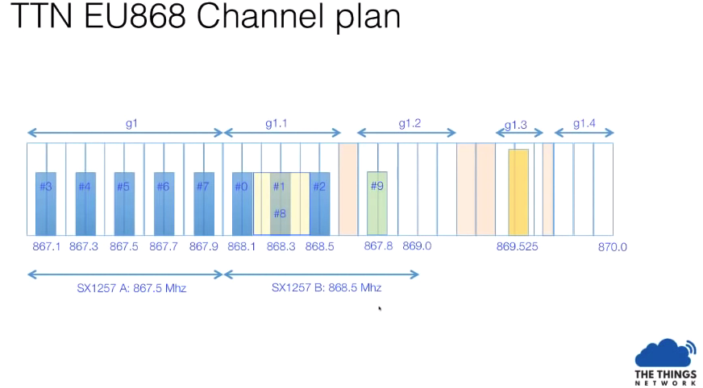

* The third band: 868,7 to 869,2MHz has 50Khz and is a 25mW area but the duty cycle is 0.1%. This zone can be interesting to communicate when an objet is emitting once a day : the risk of collision is really lower and the number of time you will have to re-emit is, as a consequence, lower, so in this sub band you can expect to preserve your energy.
* The fourth band: 869,3 to 869,4MHz has 100KHz and is not usable for LPWAN as the maximum power is 10mW but there is no duty-cycle limit and so it can be a good area for local object communication
* The fifth band: The 869,4 to 869,65MHz has 250Khz is a 500mW with a 10% duty cycle. This band is more applicable for the central network access point (Gateway) and a good channel for downlink communications (as is used in LoRaWan). The gateway can communicate far away and be listen over the local noise of the object ; the larger duty cycle allows the gateway to communicate with many objects.
* The last band: 869,7 to 870MHz has 300KHz and is a 25mW / 1% duty cycle where you can deploy extra LoRaWan channels.

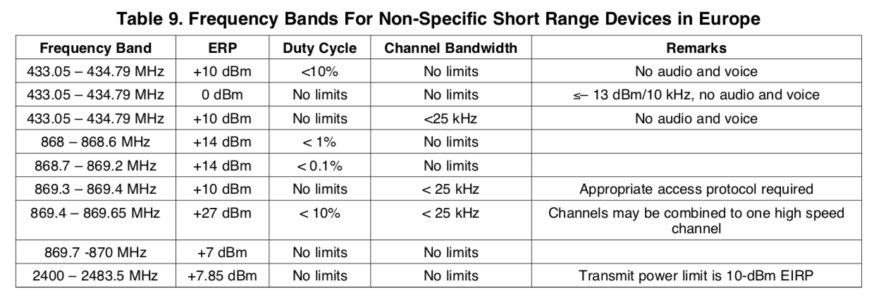

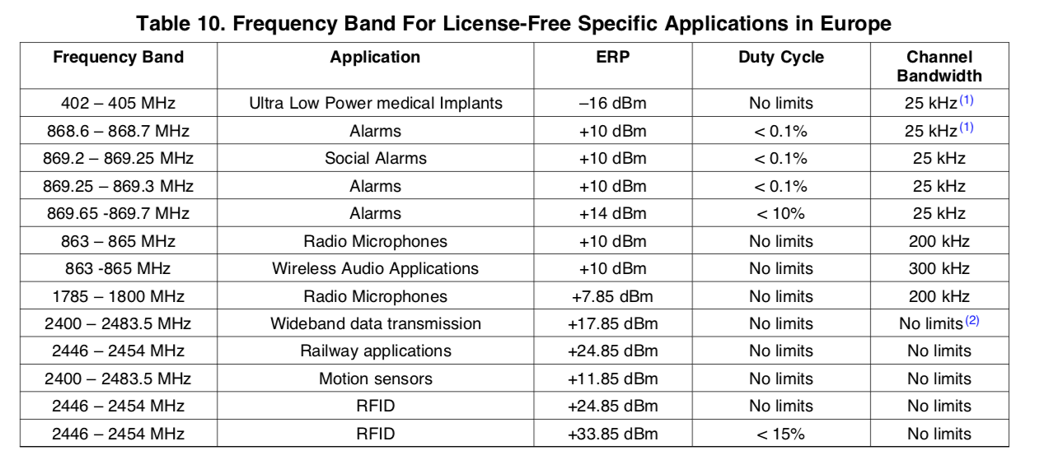

The transmission rules are based on 2 restrictions:

* Transmission power – it is the maximum power an emitter can use on the channel when it is communicating. 25mW (eq 14dB) is the usual power the LPWAN uses for communicating.
* The duty cycle – it is defined as the maximum ratio of time on the air per hour. Basically, 1% means you can speak 36s per hour, not more. Duty Cycle is applicable for the sub-band. So transmitting on several sub-bands it is possible to increase the duty cycle (e.g. transmit in 865.0Mhz band and 868Mhz band it is possible to reach 2%). However if several channels are used in the same band then the ratio of time is accordingly reduced (e.g. in LoraWAN the standard configuration is to have 3 channels in the same sub-band the duty-cycle of each of the channel is 0,33%)

# Range analysis

PWD wants to have the highest range with the lowest power consumption. There are 2 ways to get the longest range or maximize the link budget:

* **The hardware way** includes better and higher antennas and more power.
* **The software way** to get the longest range is using the Lora characteristics.

## Maximizing the link budget

The Link Budget is how many dBs you can lose between the transmitter and the receiver. Higher link budgets directly translate to longer distances (6dB = twice distance).

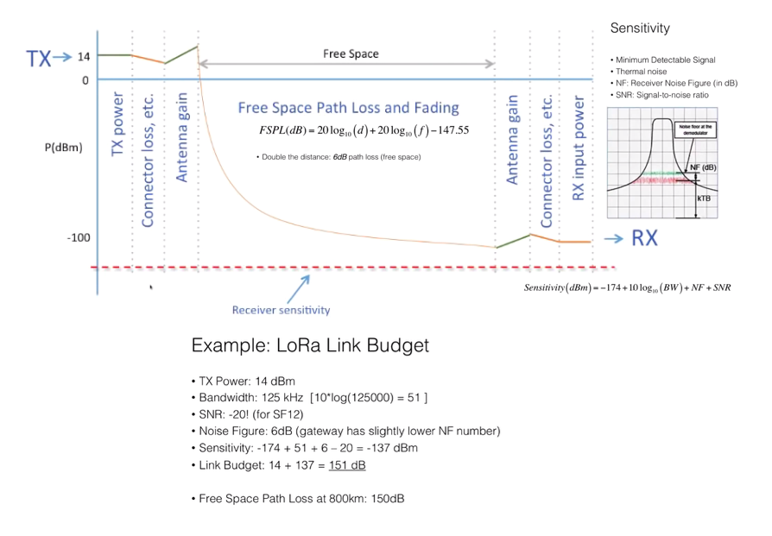

### RSSI and SNR

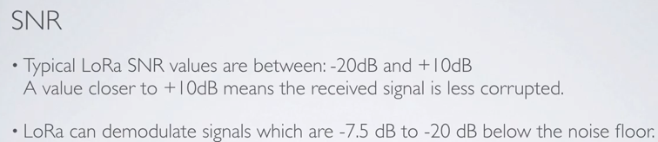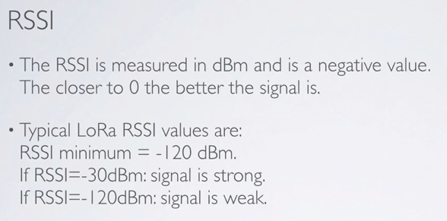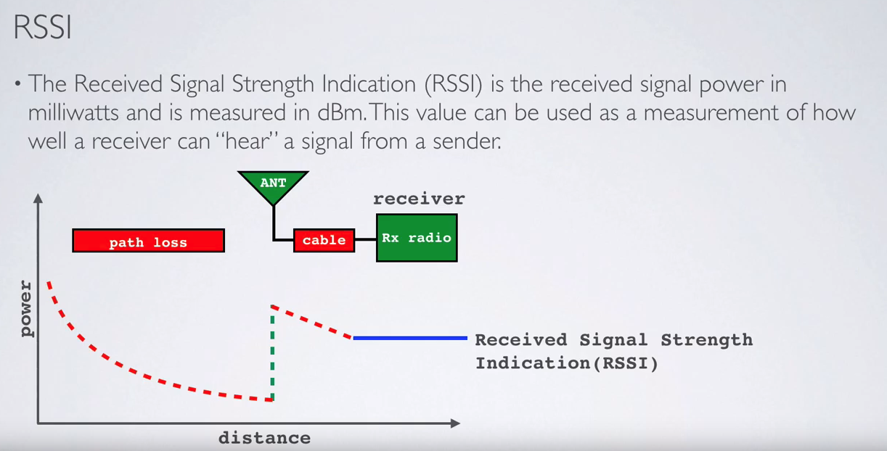

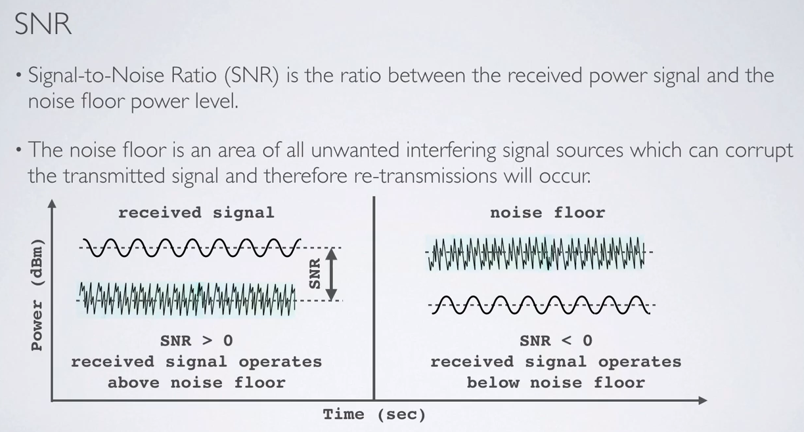

Case of Lora

### FSPL and other effects

In reality there are several effects that reduce the Free Space Path Loss and Fading further:

* Multipath (diffraction and reflection)
* Obstruction (structure attenuation)
* Fresnel zone (where the heights of the transmitter and receiver matter)

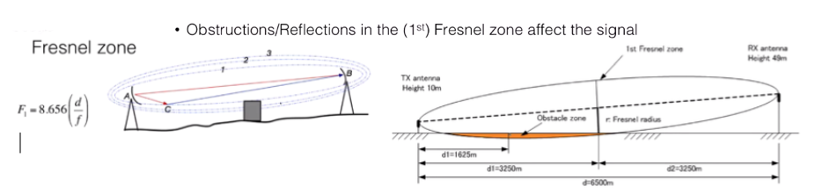

Figure 5 - The antenna height impacts link budget - https://www.youtube.com/watch?v=T3dGLqZrjIQ&feature=youtu.be

## Optimizing Link Budget: the Hardware way

### Antennas

In order to maximize the link budget the antenna also must follow some considerations

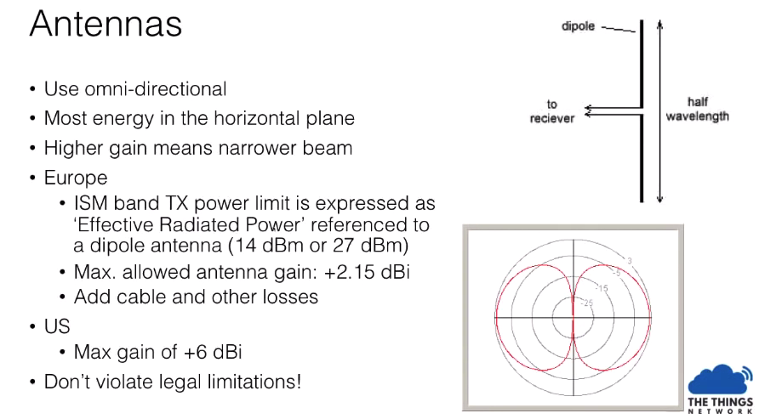

For antenna optimization see tutorials:

* Impedance: <https://www.youtube.com/watch?v=tBrwqSYvjjs&list=PLmL13yqb6OxdeOi97EvI8QeO8o-PqeQ0g&index=34>
* VSWR: <https://www.youtube.com/watch?v=c7Hum0DuXEo&list=PLmL13yqb6OxdeOi97EvI8QeO8o-PqeQ0g&index=35>
* Balun:<https://www.youtube.com/watch?v=dIFUjNcQifM&list=PLmL13yqb6OxdeOi97EvI8QeO8o-PqeQ0g&index=39>

### Receptor

It is possible to increase the receiver antenna sensitivity by limiting the amount of external noise coming into the LoRa receiver antenna input. This can be achieved by using a bandpass filter (also called a LNA – Low Noise Amplifier). From the tests in <http://www.loratracker.uk/?p=591> it seems that if we operate at SF7 there is no advantage to the LNA. **However if we work at SF12 by applying a LNA we can get 7dB to the link margin (which would mean double the distance).**

## Optimizing Link Budget: the software way

LoRa uses a spread-spectrum technique called CSS (Chirp Spread Spectrum). A chirp is a sinusoidal signal of frequency increase or decrease over time.

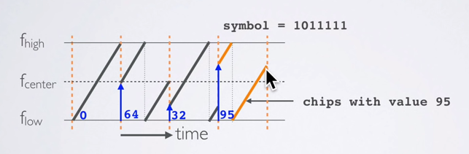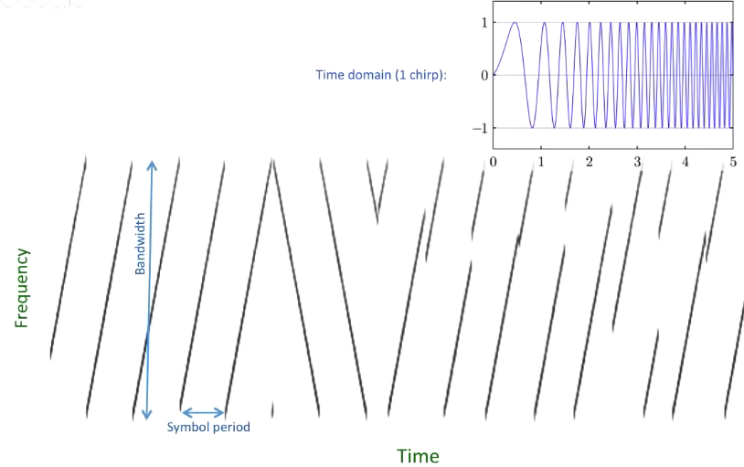

A jump in frequency is a data symbol. The jump varies in the number of “chips” – partitions of the Fhigh-Flow.

With SF7 we encode 7 bits in a symbol.

This means that the number of bits in a SF7 symbol is 2^7=128bit. Note that a “chirp” is only the frequency ramp, while a chip is a partition (bit)

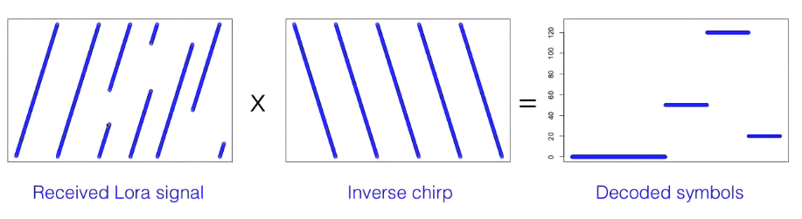

In LoRa we send chirp signals, that is the signal frequency moves up or down and these chirps are equivalent to set of symbols which when decoded give the information the sender sent. In LoRa we can change 2 factors: the bandwidth of the signal and the spreading factor. Each combination will bring a different sensitivity and also increase or decrease the data rate.

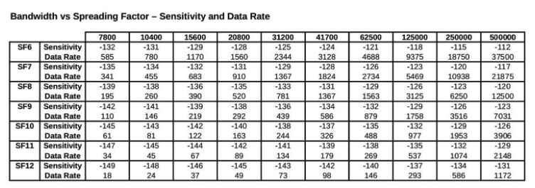

### Spreading Factor

In LoRa when we change the spreading factor, we change the speed of the moving up or down of the chirp. The speed moved is roughly 2^spreading factor. Each step up in spreading factor doubles the time on air to transmit the same amount of data.

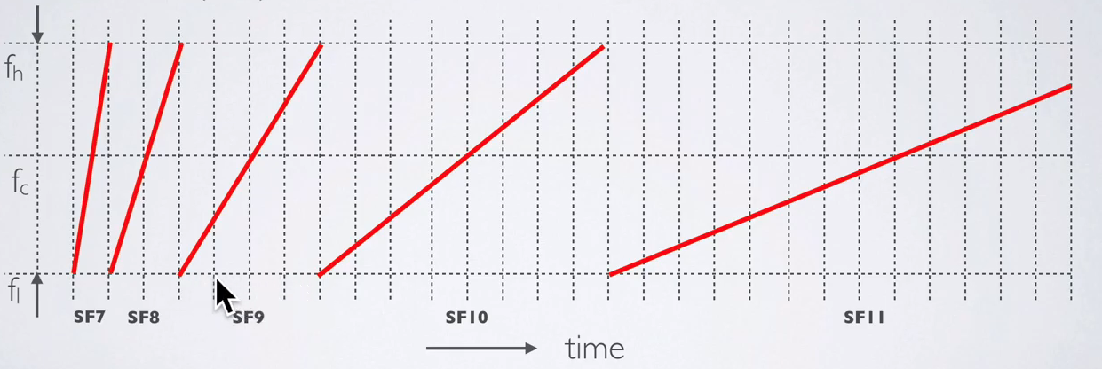

Higher spreading factors are more resistant to local noise effects and will be read more reliably at the cost of **lower data rate** and more congestion. **Each unit increase in SF correlates to about 2.5dB extra link budget**. This is because for each SF increase we increase the sensitivity at the receptor

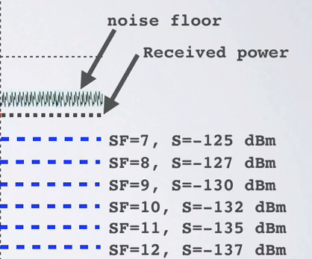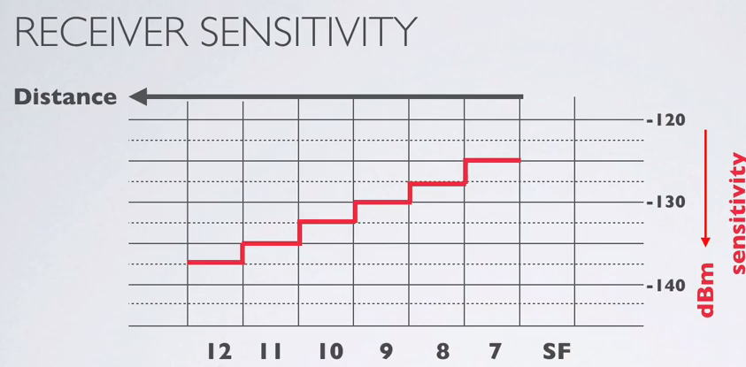

Why is this gain in link budget? Because basically we put more energy to the air/more time the sender is active.

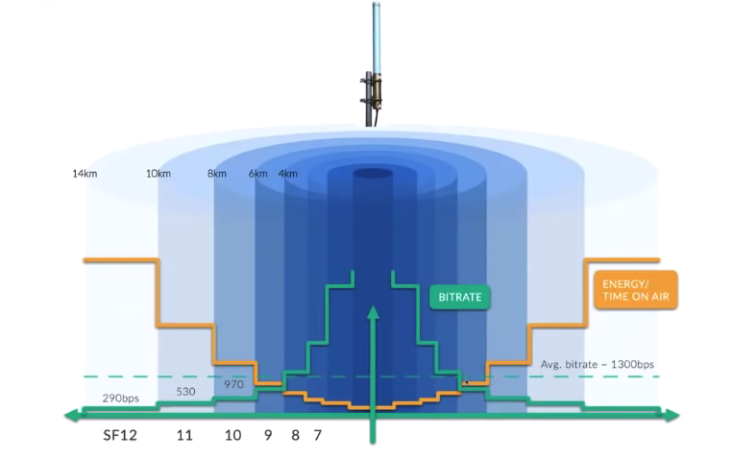

### Bandwidth

The chirp will be sent over a bandwidth. Higher bandwidth has higher data rates but more congestion. Lower bandwidth will have lower data rates but less possibility of congestion (interference from other LoRA channels). However there is a problem with lowering the BW (see frequency variation) **Each doubling of the bandwidth correlates to almost 3dB less link budget.**

### Frequency variation

So it would seem that to have the highest link budget we would only have to increase the SF (Spreading Factor) and decrease the BW (bandwidth). However there are some limitations to the BW. If let’s say we reduce the BW to 7.8KHz the signal is much more susceptible to the Chip base crystal oscillator frequency deviation. According to Semtech the maximum frequency tolerance 25% of the LoRa modulation (better to use 20% in real case situations). So for 7.8KHz we would get 1.56KHz of accuracy.

However in practice these cheap oscillators sometimes get maximum of +/- 5khz accuracy[1]. In these cases the maximum resolution would be 10Khz. This means that we would have to use a BW of >50KHz. In the case of the SandeepMistry LoRa library[2] the available bandwidths are: 7.8E3, 10.4E3, 15.6E3, 20.8E3, 31.25E3, 41.7E3, 62.5E3, 125E3, and 250E3 Hz. **So the next possible BW would be 62.5KHz**. In the TTN LoraWAN they use 125KHz BW to avoid this problem.

So in summary decreasing the bandwidth increases the risk of miscommunication due to frequency drift and inaccuracy. The Pycom and the Semtech Sx1272 only support 125KHz and above, for example. The Semtech Sx1262 and Sx1276 chipsets support bandwidths down to 8KHz.

### Frequency and temperature compensation

Frequency drift and inaccuracy are also dependent on temperature and this may be a problem for wearable technology. It is however possible to improve the temperature stability of the LoRa systems. We need to examine the temperature characteristics of the LoRa module and then alter the center frequency based on the known temperature drift. Note that the modules have a temperature sensor (albeit it’s slow and clunky). Using a derived equation from that test **it is possible to program an algorithm and then correct the center frequency based on temperature changes to maintain a connection at the desired bandwidth.**



Fn = Fc + Scale*(Temp — 80) (ºf)

### Coding rate

LoRa uses FEC (Forward Error Correction) which is the process where bits are added to the transmitted data. These redundant bits help restore the data when it gets corrupted by interference. In LoRa the FEC coding rate (CR) is the proportion of the transmitted bits that actually carry information versus the correction bits. That is CR=4/(4+correction bits) and the values can be CR=4/5,4/6,4/7.4/8.

The CR rate is multiplied by the SF to know the amount of actual bits are sent (SF=8 x CR=4/8 is 8x4/8=4 actual bits of payload.)

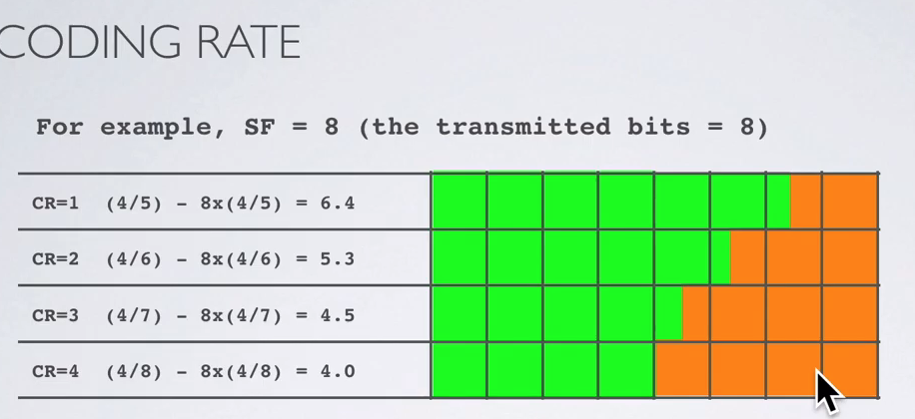

### Bit rate

The bit rate is calculated as follows:

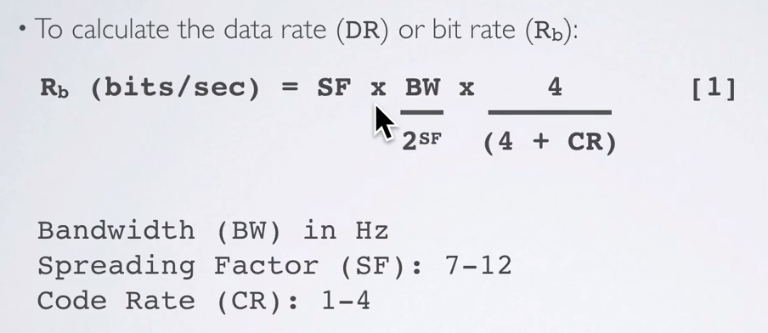

### Maximize range Summary

* Minimize bandwidth while still maintaining connection
* Maximize spreading factor to boost link budget.
* Maximize coding rate to boost reliability.

# LoRa Data packet

The LoRa data packet is constituted by a preamble, payload and CRC.

There are 2 options of payload to choose from:

* Explicit header mode: includes the Payload length and indicates if an additional/optional 16 bits CRC is present.
* Implicit header mode: which includes the only the preamble (for the receiver to detect the signal and sync) and the payload CRC **🡪 thus reducing the transmission time**

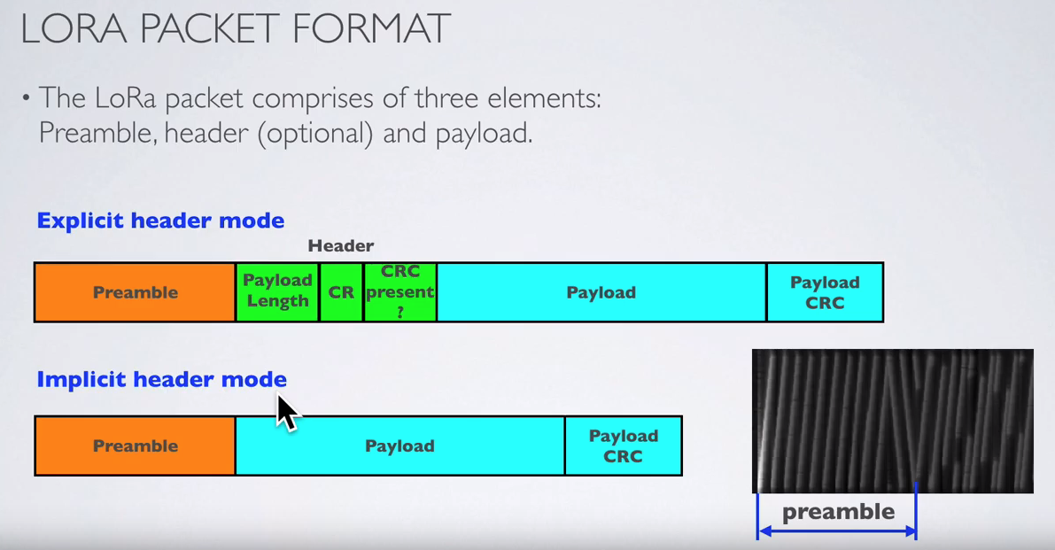

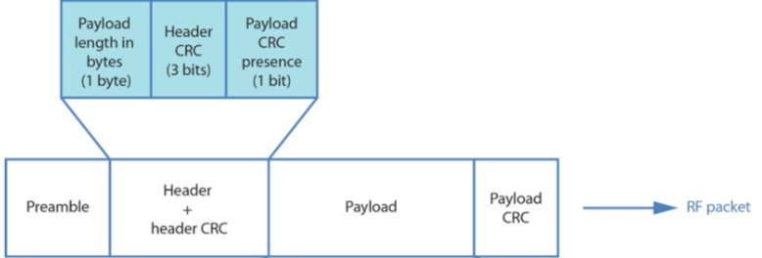

So from the previous considerations we know we want to reduce the size of the payload since the Preamble+Header+HeaderCRC+Payload CRC are not optional and already take some bytes.

## Low data rate optimization

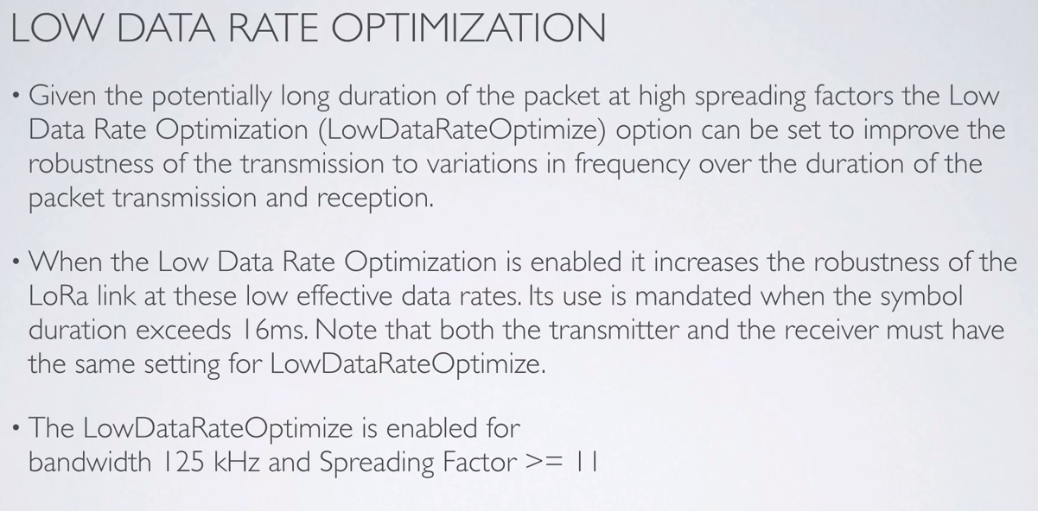

## Time on Air and Data Rate

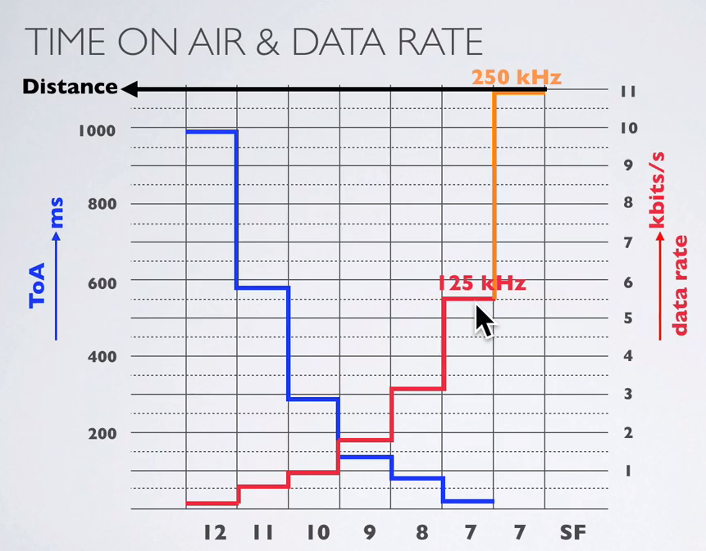

## Reducing the payload

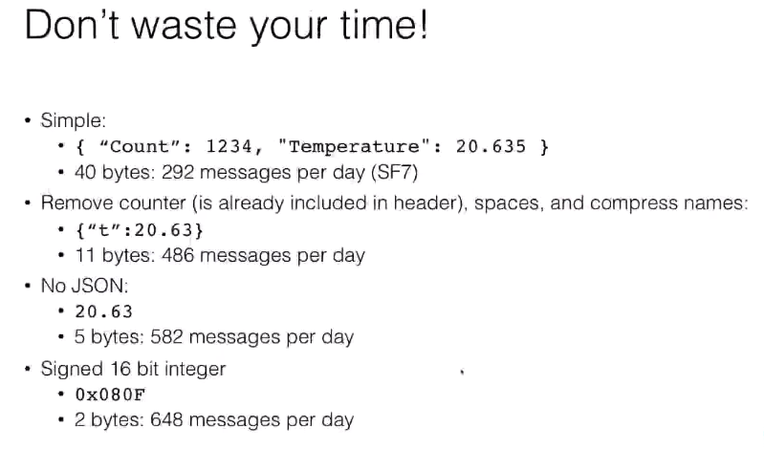

So we should aim to send as little data as possible. Possibly 32bits which would mean 4 bytes (instead of the 64 bytes we are currently using).

# Software

## LoRa end node libraries

There are several LoRa MAC end node libraries:

* Semtech LoRaMac-node library.
  + Available here: <https://github.com/Lora-net/LoRaMac-node>.
  + It is tested for NAMote72, NucleoLxxx, SKiM880B/980A/881AXL and SAML21 end nodes.
  + Porting to other platforms is available at: <http://stackforce.github.io/LoRaMac-doc/_p_o_r_t_i_n_g__g_u_i_d_e.html>
* IBM LMIC[3] library.
  + Available here: <https://github.com/lmic-lib/lmic>
  + No development since 2015, and not for Arduino.
* Arduino LMIC library connects to the transceiver via SPI low-level interface
  + This is a Arduino port of the IBM version maintained by Kooijman and Telkamp.
  + Available here: https://github.com/matthijskooijman/arduino-lmic .
  + It supports LoraWAN class A and B and for EU-868 and US-915 bands. This version is supported in SX1272, SX1276 tranceivers and compatible modules (such as some HopeRF RFM9x modules)
  + This library cannot be used with full-stack devices like the Microchip RN2483 which contains a transceiver and microcontroller and exposes a high-level serial interface.

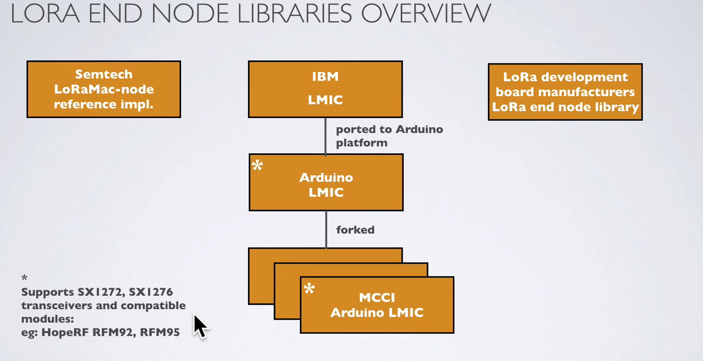

# References

## Radio theory basics

* RF 101 series (Bob Baxley): <https://www.bastille.net/resources/education-radio-frequency-101>
* LoRa video tutorial: <https://www.youtube.com/playlist?list=PLmL13yqb6OxdeOi97EvI8QeO8o-PqeQ0g>

## Waterproofing

* IP68: No ingress of dust/ Immersion, 1 m up to 3m: <https://en.wikipedia.org/wiki/IP_Code>

## LoRa Implementations

* Libelium waspmote: <http://www.libelium.com/development/waspmote/documentation/waspmote-lora-868mhz-915mhz-sx1272-networking-guide/>
* Pycom: <https://pycom.io/wp-content/uploads/2018/11/DETAILED-PYGO-SPECIFICATIONS-For-Developers-V1.2.pdf>
* Pylife and PyGo: <https://pycom.io/wp-content/uploads/2018/11/Pylife-and-PyGo-Kickstarter-FAQ-19Nov2018.pdf>

## Power legal limits

* Limits on Lora radio power emitted to: <https://stackoverflow.com/questions/50395087/lora-point-to-point-limitations>
* RF regulations in Europe

<https://www.disk91.com/2017/technology/internet-of-things-technology/all-what-you-need-to-know-about-regulation-on-rf-868mhz-for-lpwan/> and ERC-REC-70-3E: <https://www.ecodocdb.dk/download/25c41779-cd6e/Rec7003e.pdf> and Texas Instruments analysis: <http://www.ti.com/lit/an/swra048/swra048.pdf>

* LoRa calculator: <https://www.quora.com/How-much-data-at-a-time-can-be-transmitted-received-over-LoRaWAN-connections-Also-same-question-for-LoRa-point-to-point>
* LoraWAN specification: <https://lora-alliance.org/resource-hub/lorawanr-specification-v11>
* Thesis on usage of randomness to avoid jamming: <https://fenix.tecnico.ulisboa.pt/downloadFile/1126295043835530/Nuno%20Nico.pdf>

## LoRa Calculators

* Lora Alliand Duty Cycle: <https://docs.google.com/spreadsheets/d/1QvcKsGeTTPpr9icj4XkKXq4r2zTc2j0gsHLrnplzM3I/edit#gid=0>
* Semtech Lora Modem Calculator Tool: <https://sx1272-lora-calculator.software.informer.com/download/> and <https://www.elektroniknet.de/elektronik/kommunikation/nb-iot-nb-lte-oder-lte-cat-nb1-134629-Seite-3.html>
* Lora AirTime calculator: <https://www.loratools.nl/#/airtime>
* Lora data rate calculator: <https://www.rfwireless-world.com/calculators/LoRa-Data-Rate-Calculator.html> and LoRa Link Budget calculator: <https://www.rfwireless-world.com/calculators/LoRa-Link-Budget-Calculator.html>
* Best LoRa settings for Range and Reliability: <https://medium.com/home-wireless/testing-lora-radios-with-the-limesdr-mini-part-2-37fa481217ff>

## Microchip transceivers

* RN2483 LoRa wireless transceiver: <https://www.rfwireless-world.com/ApplicationNotes/LoRa-transceiver.html>

## Antenna testing

* <https://github.com/LoRaTracker/AntennaTesting>

## LoRa Packets

* <https://hackmd.io/@hVCY-lCeTGeM0rEcouirxQ/S1kg6Ymo-?type=view>

1. As mentioned in: <http://www.loratracker.uk/?m=201801>
2. <https://github.com/sandeepmistry/arduino-LoRa/blob/master/API.md>
3. LMIC is LoRa MAC in C